Python -03 | Assignment 6th may 2026 | Machine Learning

Do While loop
Python code | Output
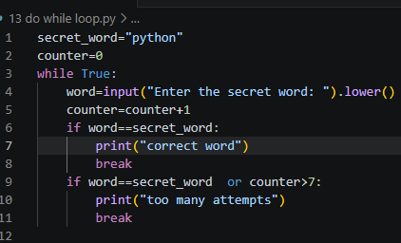 | 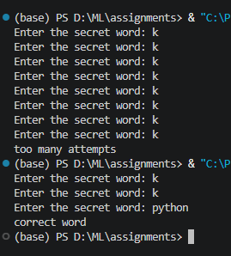

Types of function arguments
- Default argument
Python code | output
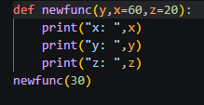 | 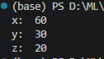

- Keyword Argument
Python code | Output
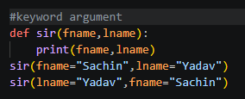 | 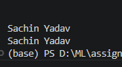

- Positional Arguments
Python code | output
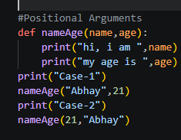 | 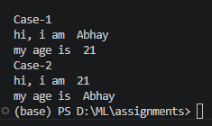

- Arbitrary Arguments
Python code | output
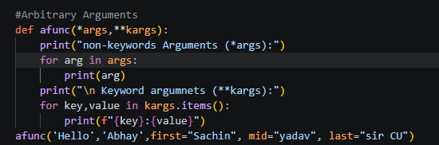 | 